CLINICAL TRIAL PATIENT MATCHING SYSTEM



Submitted By: Likitha Chowdary Chereddy
Student ID: 0104363
Date of submission: 3/10/2026
COMP-699-A Professional Seminar
Spring 2026
Rivier University

TABLE OF CONTENTS
1. Introduction to the organization 2
2. System Request 3
2.1 Business Need: 3
2.2 Business Requirements: 3
2.3 Business Value: 4
2.4 Special Issues or Constraints: 4
3. Requirements Definition 5
3.1 Functional Requirements 5
3.2 Non-Functional Requirements 8
4. Analysis Models 9
4.1 Use Case Diagram 9
4.1.1 Use Case Descriptions 10
4.2 Activity diagram 12
4.3 Sequence diagrams 13
4.3.1 Manage Patient & Clinical Data 13
4.3.2 Register Trial & Configure Eligibility Rules 14
4.3.3 Run Match, Rank Results, Categorize 15
4.3.4 View Explanation, Recommendations, Compare Trails 16
4.3.5 Generate Match Report, View History, Enrollment Info 17
4.3.6 Screening Workflow, Notifications, Recruitment Report 18
4.4 Class diagram 19
4.4.1 Class-to-Use Case Mapping Table 20
4.5 Object diagram 21
5. Design and Implementation Considerations 22
6. References 23

Introduction to the organization

MedConnect Research Solutions is a clinical research coordination organization that supports hospitals, medical centers, and pharmaceutical companies in managing and recruiting participants for clinical trials. The organization works with multiple healthcare institutions and assists researchers in identifying suitable patients for ongoing clinical trials. Clinical trials are essential for evaluating new medical treatments, drugs, and healthcare interventions. However, identifying eligible patients for these trials is often a complex and time-consuming process that requires careful review of patient medical information and clinical trial eligibility criteria.
Currently, research coordinators must manually review patient medical records and compare them with the inclusion and exclusion criteria defined in clinical trial protocols. This manual process requires coordinators to analyze large amounts of patient information, including diagnoses, laboratory results, medications, treatment history, and genetic markers. Because clinical trial protocols often contain lengthy and complex eligibility requirements, this process can take significant time for each patient evaluation. As a result, research teams face delays in identifying eligible participants, which can slow down clinical trial recruitment and increase operational costs.
The manual approach also introduces the possibility of inconsistencies in eligibility evaluation. Different coordinators may interpret eligibility criteria differently, which can lead to inconsistent screening decisions. Additionally, the increasing number of clinical trials and the growing complexity of medical data make it difficult for research staff to scale the recruitment process efficiently. These challenges highlight the need for a system that can systematically analyze patient data and assist coordinators in identifying potential clinical trial matches more efficiently.
To address these challenges, this project proposes the development of the Clinical Trial Patient Matching System (CTPMS). The goal of this system is to automate the process of evaluating patient eligibility for clinical trials using a structured, rule-based approach. The system will allow research coordinators to manage patient medical profiles, register clinical trials, define eligibility criteria using structured rules, and automatically compare patient data against trial requirements. By performing automated evaluations and ranking potential matches, the system will help coordinators quickly identify promising trial opportunities for patients.
The Clinical Trial Patient Matching System is designed to improve efficiency, consistency, and transparency in the clinical trial recruitment process. By reducing the need for manual review and providing clear explanations for eligibility decisions, the system will support research coordinators in making faster and more reliable screening decisions. Ultimately, the system aims to accelerate patient recruitment for clinical trials while improving the overall management of trial eligibility evaluation. Improving the efficiency of clinical trial recruitment and eligibility evaluation has become an important area of research in healthcare information systems (Lee et al., 2021).

System Request

Business Need:
Clinical trials are essential for advancing medical treatments, yet patient recruitment remains a significant bottleneck in medical research. Research coordinators currently spend substantial time manually reviewing patient medical records against complex trial eligibility criteria, a process that is time-consuming, error-prone, and inefficient. Many trials fail to meet recruitment timelines due to difficulties identifying and enrolling eligible patients.
The current manual process requires coordinators to interpret extensive inclusion and exclusion criteria across multiple trials and compare them against patient data stored in disparate systems. This results in missed enrollment opportunities, delayed research outcomes, and inefficient use of clinical resources. There is a clear need for a centralized system that can systematically evaluate patient eligibility and support screening workflows.

Business Requirements:
- Automated evaluation of patient medical profiles against structured clinical trial eligibility criteria
- Support for inclusion and exclusion rules including age ranges, diagnoses, laboratory values, medications, and treatment history
- Generation of clear eligibility outcomes (Eligible, Ineligible, Needs Review) with detailed rule-based explanations
- Management of a clinical trial registry with configurable eligibility criteria represented as evaluable rule sets
- Comprehensive patient profile management including demographics, diagnoses, medications, laboratory results, and treatment history
- Rule-based scoring and prioritization logic to assist coordinators in identifying high-probability matches
- Screening workflow management including review queues, approval steps, and enrollment tracking
- Audit logging of eligibility evaluations, reviewer decisions, and workflow transitions
- Reporting on recruitment progress, exclusion reasons, and screening efficiency

Business Value:
The Clinical Trial Patient Matching System is expected to significantly reduce the time and effort required to identify eligible trial participants while improving consistency and transparency in screening decisions. By automating eligibility evaluation and managing screening workflows, research teams can focus on patient engagement and trial execution rather than manual data review.
Conservative estimates of tangible value include:
• Reduction of manual screening time by 60–70%, enabling coordinators to review substantially more patients per day
• Improved enrollment rates through consistent identification of eligible candidates
• Estimated cost savings of $25,000–$35,000 annually per research coordinator due to reduced manual effort
Additional intangible benefits include faster trial timelines, improved auditability of screening decisions, and better utilization of research resources.

Special Issues or Constraints:
- The system must be implemented entirely in Python using object-oriented analysis and design principles
- Core functionality must demonstrate significant custom business logic and rule processing rather than configuration of existing frameworks
- The system must be fully demonstrable as a working prototype by the end of the semester
- Synthetic patient data and simulated clinical trial data will be used; no real patient or protected health information will be included
- Data models will be designed with privacy and security principles in mind, although full HIPAA compliance infrastructure is outside the scope of this project
- AI/ML Clarification: This system does not rely on machine learning or trained AI models. Patient-trial matching is performed using deterministic, rule-based eligibility evaluation, weighted scoring logic, and predefined medical criteria rather than predictive or trained models.

Structured system analysis and design approaches are commonly used to develop reliable and scalable information systems that support complex decision workflows (Dennis et al., 2020).

Requirements Definition
The Requirements Definition section describes the functional and non-functional requirements of the Clinical Trial Patient Matching System (CTPMS). These requirements define the capabilities and constraints of the proposed system and serve as the foundation for the system analysis models presented later in this document. Functional requirements describe the services and operations the system must provide to users, while non-functional requirements define system performance, security, and technical constraints.

Functional Requirements
Functional requirements describe the specific operations that the system must perform in order to support research coordinators, trial administrators, and system administrators. These requirements define how users interact with the system and how patient data, clinical trial information, and eligibility evaluations are managed within the system.
The following functional requirements define the core capabilities of the Clinical Trial Patient Matching System.
FR-1: Research coordinators shall be able to create, update, and view patient profiles including demographic information (patient ID, date of birth, gender, ethnicity).
FR-2: Research coordinators shall be able to add, update, and delete diagnoses for a patient including ICD-10 code, diagnosis description, and diagnosis date.
FR-3: Research coordinators shall be able to add, update, and delete current medications for a patient including drug name, dosage, frequency, route of administration, and start date.
FR-4: Research coordinators shall be able to enter, update, and delete laboratory test results for a patient including test name, result value, measurement unit, reference range, and test date.
FR-5: Research coordinators shall be able to record, update, and delete prior treatment history for a patient including previous therapies, surgical procedures, radiation treatments, dates, and outcomes.
FR-6: Research coordinators shall be able to record, update, and delete genetic marker and biomarker test results for a patient including marker name, result (positive/negative or numeric value), and test date.
FR-7: Research coordinators shall be able to record and update performance status measurements for a patient including ECOG score, Karnofsky score, and assessment date.
FR-8: Research coordinators shall be able to search for patient profiles using patient ID, name, or diagnosis code.
FR-9: Research coordinators shall be able to deactivate patient profiles to exclude them from matching processes.
FR-10: Trial administrators shall be able to register new clinical trials by entering trial identification information including protocol number, NCT number, trial title, sponsor name, principal investigator, and trial phase.
FR-11: Trial administrators shall be able to specify the disease or condition focus for a trial using ICD-10 diagnosis codes.
FR-12: Trial administrators shall be able to define inclusion criteria for a trial as structured rules specifying age ranges, required diagnoses, required biomarkers, laboratory value ranges, required medications, prior treatment requirements, and performance status requirements.
FR-13: Trial administrators shall be able to define exclusion criteria for a trial as structured rules specifying prohibited diagnoses, prohibited biomarkers, prohibited laboratory values, prohibited medications, and prohibited prior treatments.
FR-14: Trial administrators shall be able to assign importance weights to each eligibility criterion on a scale of 1 to 5, where 5 indicates critical criteria and 1 indicates preferred but optional criteria.
FR-15: Trial administrators shall be able to specify logical operators (AND/OR) to create compound eligibility rules with multiple conditions.
FR-16: Trial administrators shall be able to enter and update trial logistics information including study site locations, target enrollment number, estimated study duration, and contact information for enrollment inquiries.
FR-17: Trial administrators shall be able to update trial status as Planning, Active-Enrolling, Active-Not Enrolling, Suspended, Completed, or Terminated.
FR-18: Trial administrators shall be able to update trial information and eligibility criteria when protocol amendments are approved.
FR-19: Trial administrators shall be able to search for trials using protocol number, trial title keywords, sponsor name, or disease focus.
FR-20: Research coordinators shall be able to initiate automated matching of a selected patient profile against all active clinical trials.
FR-21: Research coordinators shall be able to view match results displaying all evaluated trials ranked by match score from highest to lowest.
FR-22: Research coordinators shall be able to view match categories for each trial indicating Strong Match (80-100%), Potential Match (60-79%), Weak Match (40-59%), or Disqualified (<40% or exclusion criterion met).
FR-23: Research coordinators shall be able to view match confidence scores indicating the completeness of patient data used in the evaluation.
FR-24: Research coordinators shall be able to view detailed match explanations showing which inclusion criteria were met, not met, or could not be evaluated due to missing data.
FR-25: Research coordinators shall be able to view detailed match explanations showing which exclusion criteria were satisfied (disqualifying) or not satisfied.
FR-26: Research coordinators shall be able to view the specific patient data values that were used to evaluate each eligibility criterion.
FR-27: Research coordinators shall be able to view recommendations for additional diagnostic tests or data collection needed to improve match accuracy.
FR-28: Research coordinators shall be able to compare match explanations for multiple trials side-by-side.
FR-29: Research coordinators shall be able to generate comprehensive match reports for a patient including patient summary, list of evaluated trials with match scores and categories, qualifying factors, and disqualifying factors.
FR-30: Research coordinators shall be able to export match reports in PDF format.
FR-31: Research coordinators shall be able to view the history of all matching activities performed for a specific patient including dates and results of previous matching sessions.
FR-32: Research coordinators shall be able to view trial contact information and enrollment instructions for trials categorized as Strong Match or Potential Match.
FR-33: System administrators shall be able to create, update, deactivate, and delete user accounts for research coordinators and trial administrators.
FR-34: System administrators shall be able to assign roles (Research Coordinator, Trial Administrator, System Administrator) to user accounts.
FR-35: System administrators shall be able to reset user passwords.

Non-Functional Requirements

NFR-1: The system shall complete matching of 1 patient against 100 trials within 5 seconds on a standard laptop/desktop.
NFR-2: The system shall be implemented in Python 3.9+ using object-oriented design principles and delivered as a standalone desktop application.
NFR-3: The system shall store application data in PostgreSQL with encryption at rest enabled.
NFR-4: The system shall enforce role-based access control (RBAC) for Research Coordinators, Trial Administrators, and System Administrators.
NFR-5: The system shall encrypt stored patient records using AES-256 or equivalent strong encryption.
NFR-6: The user interface shall display match categories using consistent visual indicators (e.g., color and labels) to support quick interpretation.
NFR-7: The system shall generate an audit log entry for trial eligibility rule changes, matching executions, and screening decisions.
NFR-8: The system shall use only synthetic or simulated patient/trial data and shall not store, or process real patient protected health information (PHI).

Analysis Models

4.1 Use Case Diagram
The use-case diagram illustrates the primary interactions between system users and the Clinical Trial Patient Matching System (CTPMS). The diagram identifies the Research Coordinator, Trial Administrator, and System Administrator as the main actors interacting with the system. These actors perform operations related to patient management, clinical trial configuration, automated patient-trial matching, reporting, and system administration.
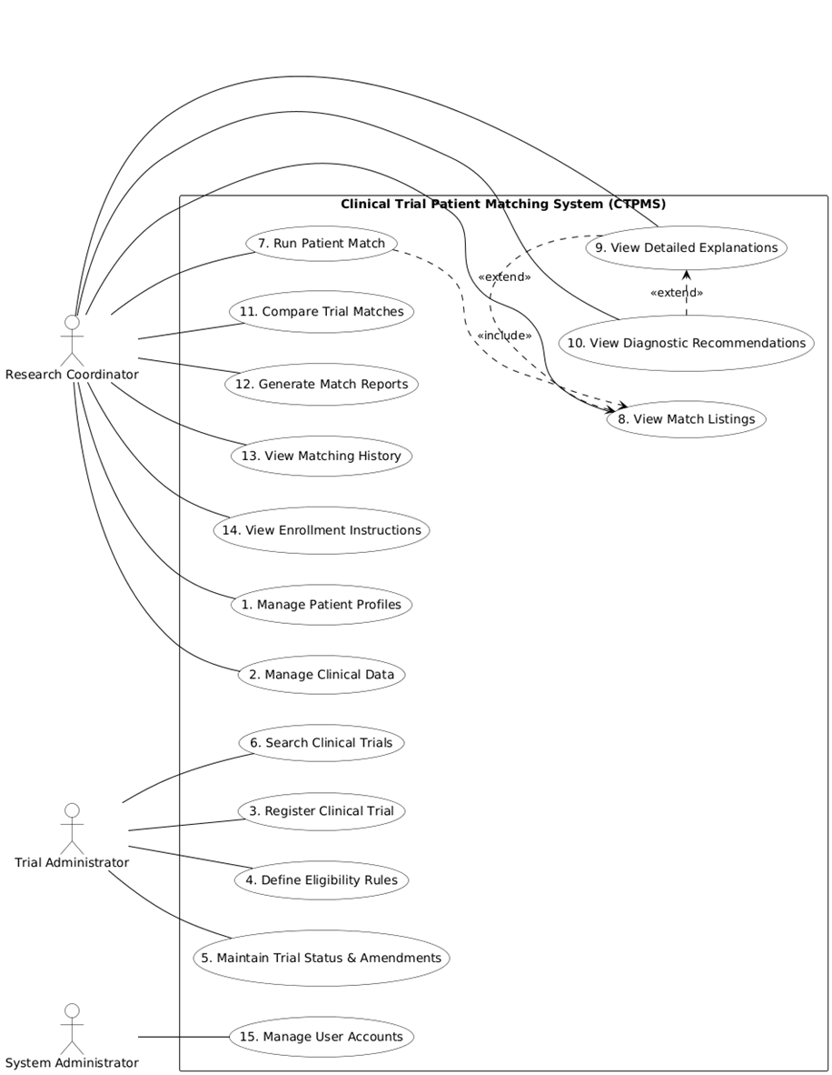
Figure 1: Use Case Diagram for the Clinical Trial Patient Matching System (CTPMS)

4.1.1 Use Case Descriptions
UC-1: Manage Patient Profile
Actor: Research Coordinator
Description: The Research Coordinator creates, updates, and views patient profiles including demographic and medical data.
Precondition: Coordinator is authenticated and logged into the system
Postcondition: Patient profile is created or updated in the system and is available for matching

UC-2: Manage Clinical Data
Actor: Research Coordinator
Description: The Research Coordinator manages diagnoses, medications, lab results, and biomarkers for patients.
Precondition: Patient profile exists
Postcondition: Clinical data is updated

UC-3: Register Clinical Trial
Actor: Trial Administrator
Description: The Trial Administrator registers a clinical trial with protocol details and disease focus.
Precondition: Admin is authenticated. Trial protocol information is available.
Postcondition: New clinical trial is registered in the system with eligibility criteria and is available for patient matching.

UC-4: Define Eligibility Rules
Actor: Trial Administrator
Description: The Trial Administrator defines inclusion and exclusion criteria using structured rules.
Precondition: Trial exists
Postcondition: Rules are stored and linked to trial

UC-5: Run Patient Matching
Actor: Research Coordinator
Description: The system evaluates patient data against clinical trial eligibility criteria and generates match results.
Precondition: An active patient profile exists. At least one active clinical trial with eligibility criteria is registered in the system.
Postcondition: A matching session is recorded. Ranked match results with scores, categories, and explanations are available for coordinator review.

UC-6: View Match Results & Explanation
Actor: Research Coordinator
Description: The user views ranked match results and detailed explanations.
Postcondition: Coordinator has viewed detailed match explanations and/or downloaded a PDF match report.

UC-7: Generate Match Report
Actor: Research Coordinator
Description: The system generates a downloadable PDF report of matching results.
Postcondition: Report is generated

UC-8: Screening Workflow
Actor: Research Coordinator
Description: The user records screening decisions and updates recruitment status.
Postcondition: Screening and recruitment data updated. Audit trail is maintained.

4.2 Activity diagram
The activity diagram illustrates the main workflow of the Clinical Trial Patient Matching System during patient-to-trial eligibility evaluation. The process begins when a research coordinator selects a patient profile and initiates the matching process. The system then validates patient data, evaluates the patient against active clinical trials, displays ranked match results, and supports follow-up review actions. This model provides a simplified view of the system’s core operational flow while remaining consistent with the functional requirements and other analysis models.
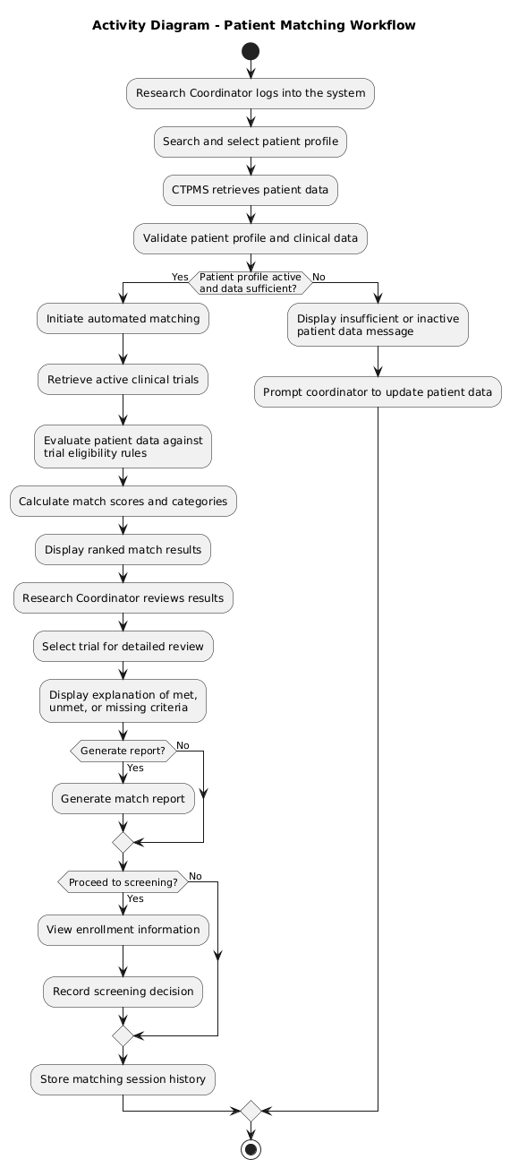

Figure 2: Activity Diagram for Patient Matching Workflow

Sequence diagrams

Manage Patient & Clinical Data
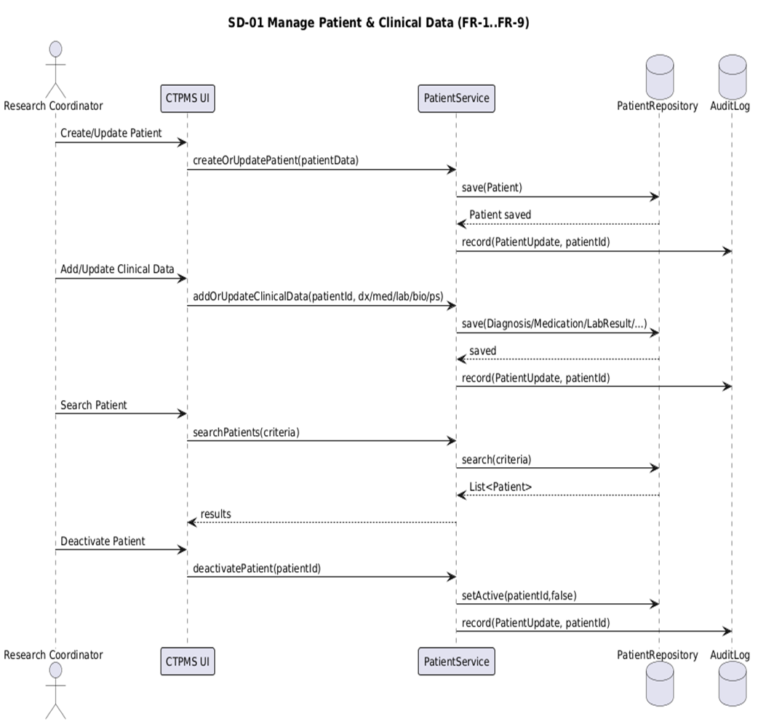
The sequence diagram shows how the Research Coordinator interacts with the Clinical Trial Patient Matching System (CTPMS) to manage patient profiles and clinical data. The CTPMS UI sends requests to the PatientService, which stores and retrieves patient records through the PatientRepository while recording updates in the AuditLog. The diagram covers operations such as creating or updating patient information, managing clinical data, searching patients, and deactivating patient profiles.
Figure 3: Sequence Diagram for Managing Patient and Clinical Data

Register Trial & Configure Eligibility Rules
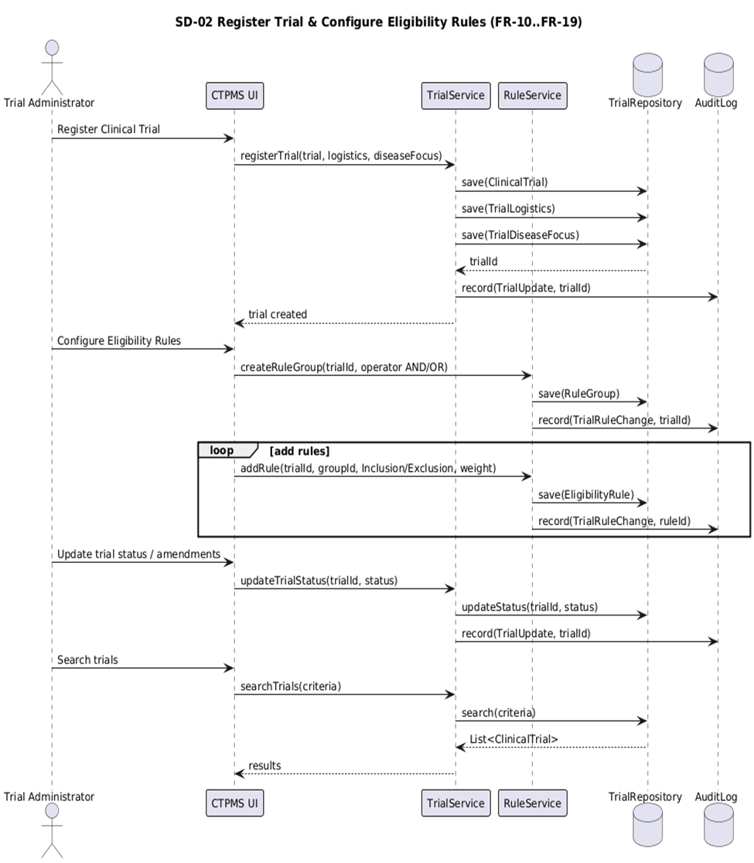
The sequence diagram shows how a Trial Administrator registers clinical trials and configures eligibility rules in the Clinical Trial Patient Matching System (CTPMS). The administrator submits trial information through the CTPMS UI, which communicates with the TrialService and RuleService to store trial details, logistics, disease focus, and eligibility rules in the TrialRepository. Audit records are generated in the AuditLog to track updates. The process also supports updating trial status and searching for registered clinical trials.
Figure 4: Sequence Diagram for Registering Clinical Trials and Configuring Eligibility Rule

Run Match, Rank Results, Categorize
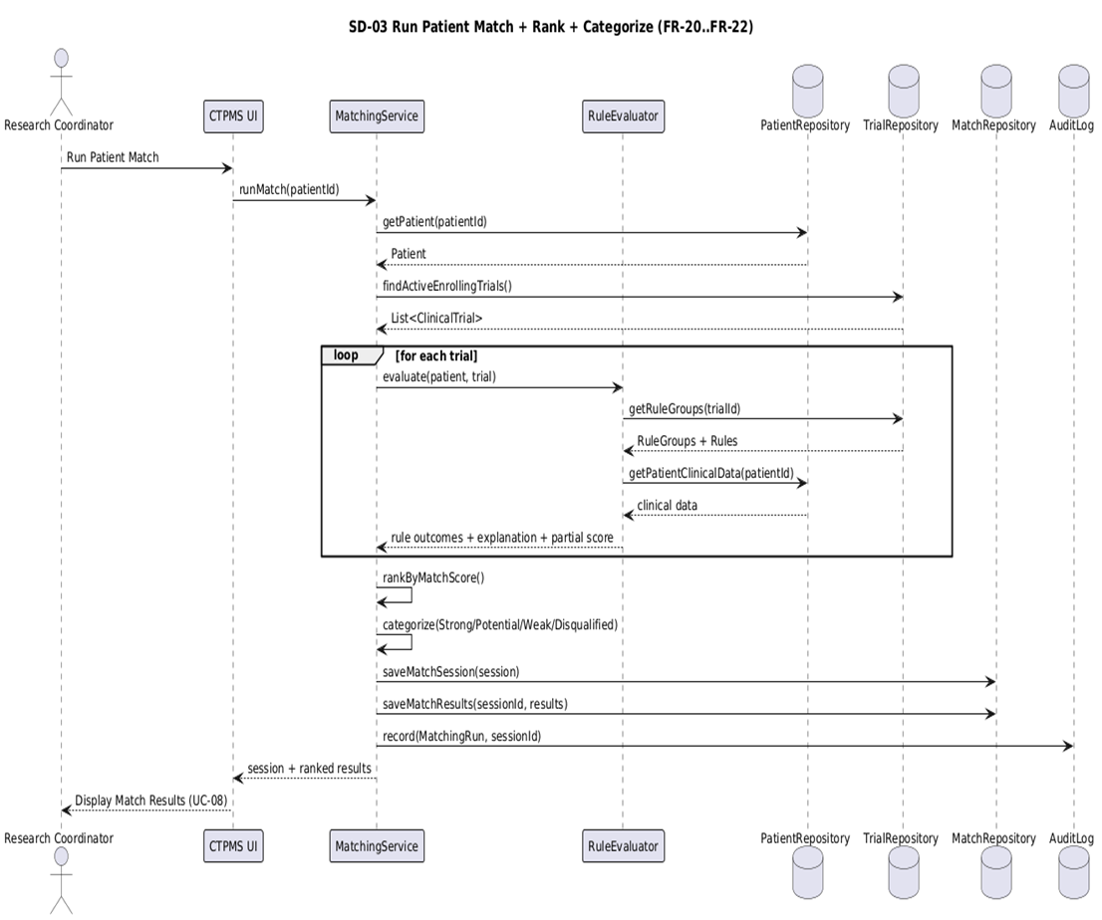
The sequence diagram illustrates how the Clinical Trial Patient Matching System performs automated patient-to-trial matching. The Research Coordinator initiates the matching process through the CTPMS UI, which triggers the MatchingService to retrieve patient data and active clinical trials. The RuleEvaluator evaluates patient information against trial eligibility rules, generates match scores and explanations, and ranks the trials. The system then categorizes the results and stores the matching session and outcomes before displaying the ranked matches to the user.
Figure 5: Sequence Diagram for Patient Matching, Ranking, and Categorization

View Explanation, Recommendations, Compare Trails
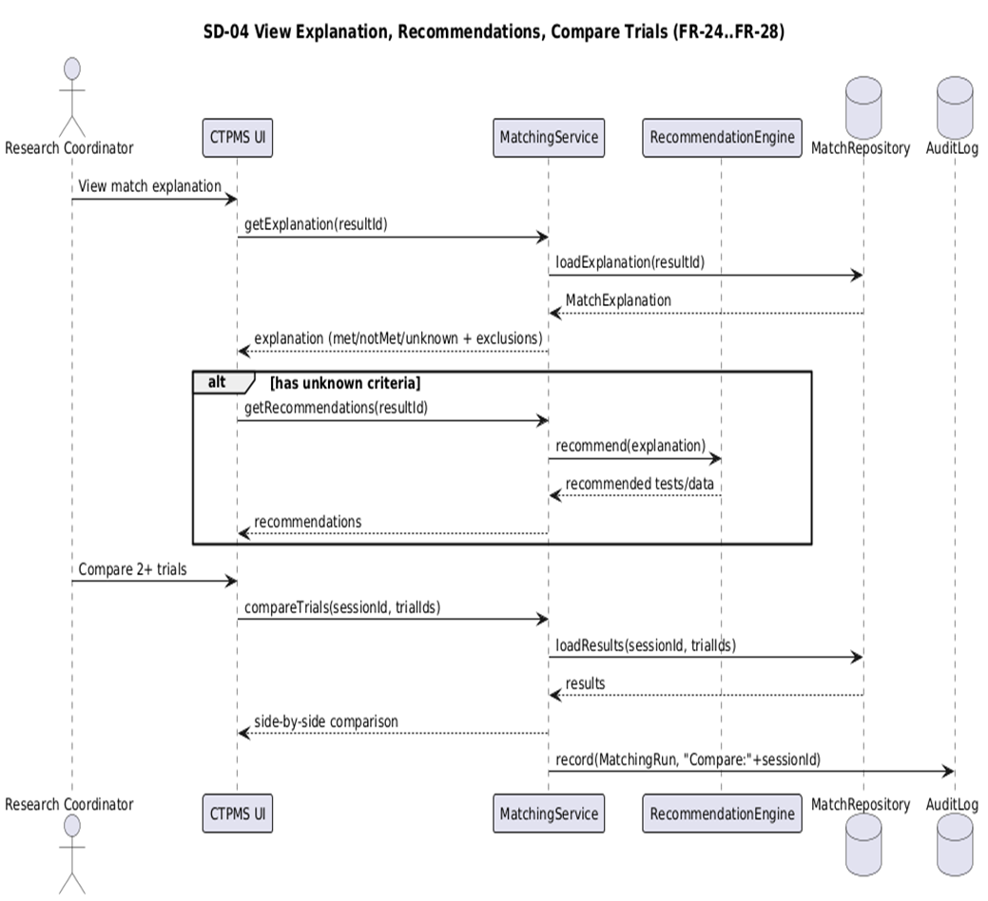
The sequence diagram illustrates how the Research Coordinator views match explanations, receives recommendations, and compares clinical trials within the Clinical Trial Patient Matching System (CTPMS). The CTPMS UI requests match explanations from the MatchingService, which retrieves evaluation results from the MatchRepository. If eligibility criteria are incomplete, the RecommendationEngine generates suggestions for additional tests or data collection. The system also allows the coordinator to compare multiple trials side-by-side and records the activity in the AuditLog.

Figure 6: Sequence Diagram for Viewing Match Explanations, Recommendations, & Comparing Trials

Generate Match Report, View History, Enrollment Info
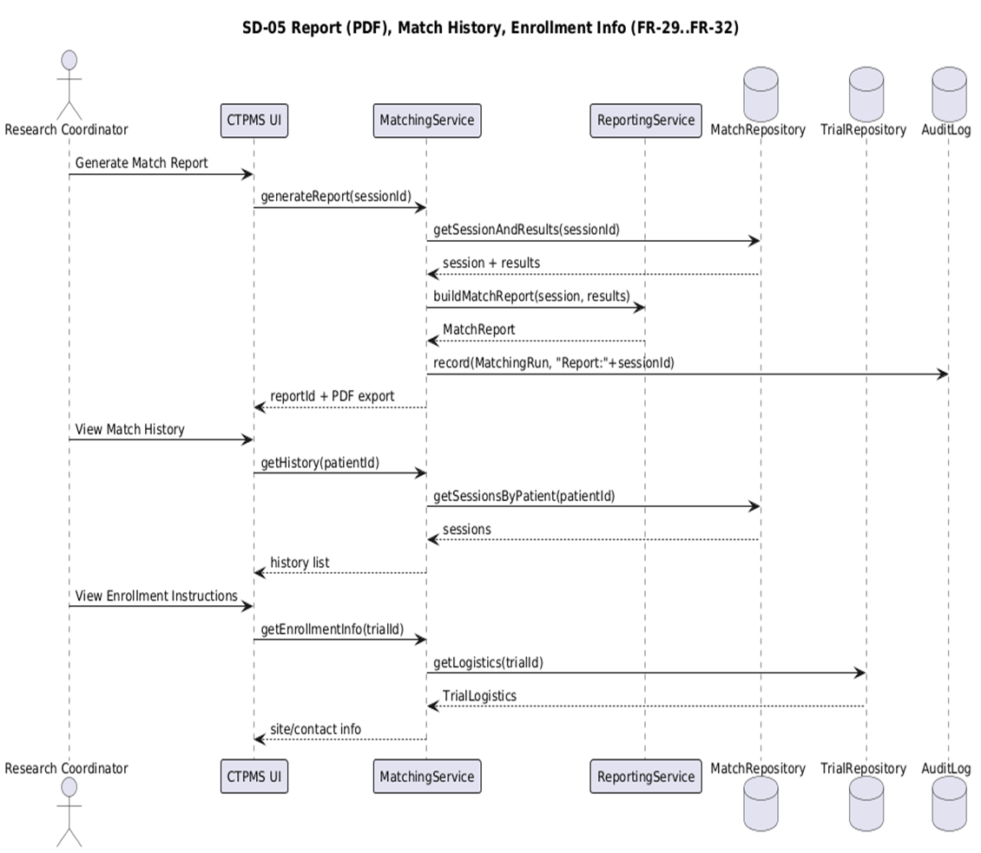
The sequence diagram shows how the Research Coordinator generates match reports, views match history, and accesses enrollment information in the Clinical Trial Patient Matching System (CTPMS). The CTPMS UI sends requests to the MatchingService and ReportingService to retrieve matching sessions, build a PDF match report, and obtain enrollment logistics from the TrialRepository. The system returns the requested information to the user while recording activities in the AuditLog for tracking and auditing purposes.
Figure 7: Sequence Diagram for Match Report Generation, Match History, and Enrollment Information

Screening Workflow, Notifications, Recruitment Report
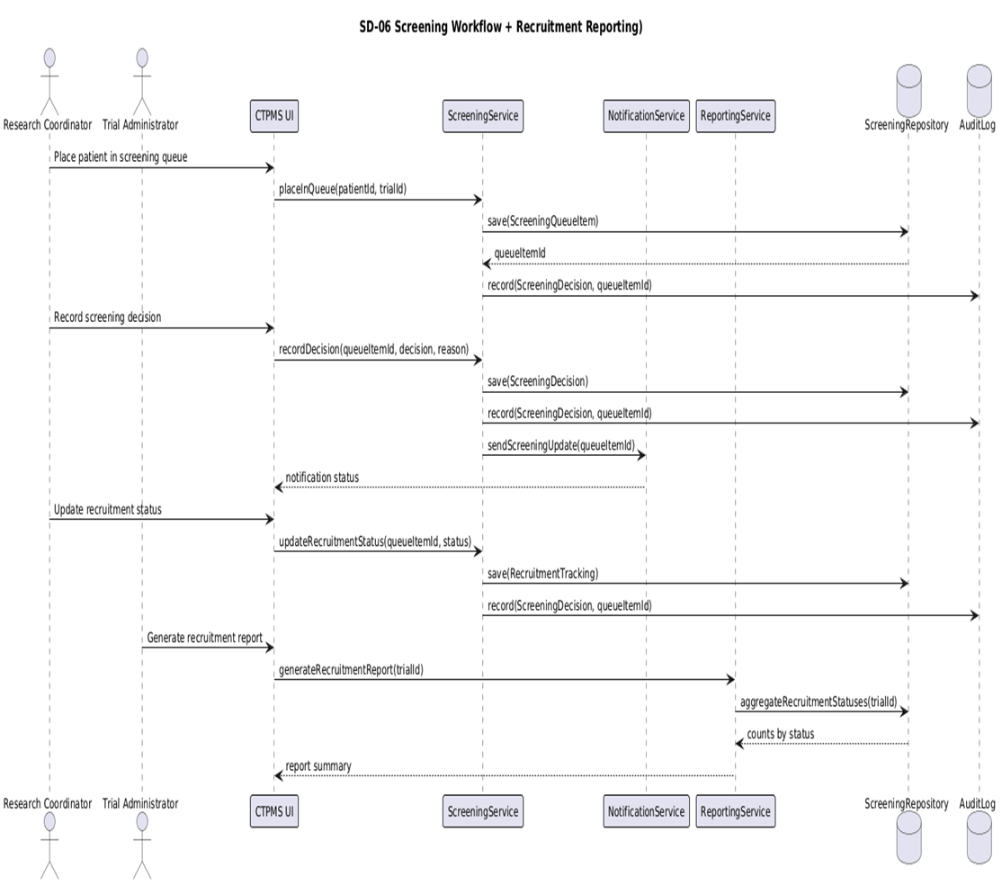
The sequence diagram illustrates the screening workflow and recruitment reporting process in the Clinical Trial Patient Matching System. The Research Coordinator places patients in the screening queue and records screening decisions through the CTPMS UI. The ScreeningService stores screening information in the ScreeningRepository and triggers notifications through the NotificationService. The system also allows users to update recruitment status and generate recruitment reports using the ReportingService, while all actions are recorded in the AuditLog.

Figure 8: Sequence Diagram for Screening Workflow and Recruitment Reporting

Class diagram
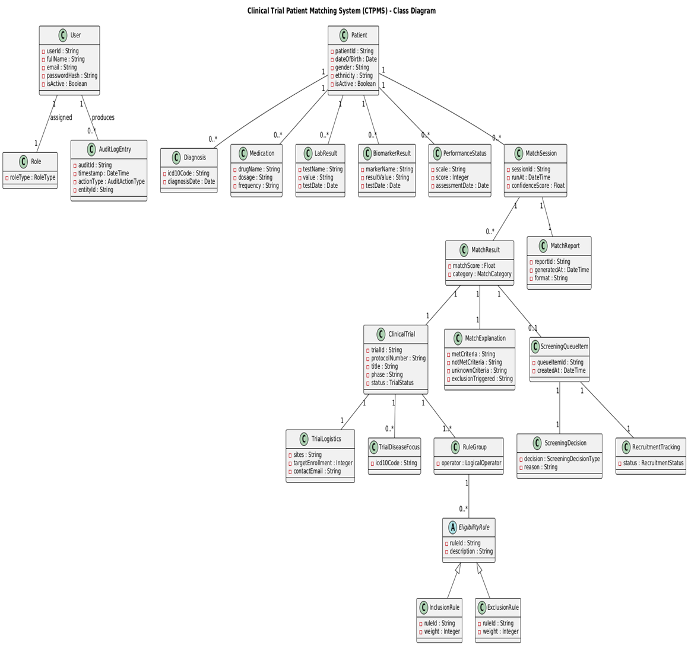
The class diagram illustrates the static structure of the Clinical Trial Patient Matching System (CTPMS). It defines the core domain classes, their attributes, and relationships used to represent patient information, clinical trials, eligibility rules, matching results, screening workflows, and system users. The diagram provides the structural foundation for the system and supports the behaviors illustrated in the sequence and activity diagrams.
Figure 9: Class Diagram for the Clinical Trial Patient Matching System (CTPMS)

4.4.1 Class-to-Use Case Mapping Table
The class-to-use case mapping table below illustrates how each class in the Clinical Trial Patient Matching System (CTPMS) supports specific use cases, ensuring consistency and traceability between the system’s functional requirements and structural design.

CLASS | USECASE ID’s | USECASE NAMES
Class | UC-1, UC-2, UC-5 | Manage Patient Profiles, Manage Clinical Data, Run Matching
Diagnosis | UC-2 | Manage Clinical Data
Medication | UC-2 | Manage Clinical Data
LabResult | UC-2 | Manage Clinical Data
BiomarkerResult | UC-2 | Manage Clinical Data
PerformanceStatus | UC-2 | Manage Clinical Data
ClinicalTrial | UC-3, UC-4, UC-5 | Register Trial, Configure Eligibility, Run Matching
TrialLogistics | UC-3 | Register Trail
TrailDiseaseFocus | UC-3 | Register Trail
EligibilityRule | UC-4 | Define Eligibility Rules
InclusionRule | UC-4 | Define Inclusion Rules
ExclusionRule | UC-4 | Define Exclusion Rules
RuleGroup | UC-4 | Configure Eligibility Logic
MatchSession | UC-5 | Run Patient Matching
MatchResult | UC-5, UC-6 | View Match Results
MatchExplanation | UC-6 | View Match Explanation
MatchReport | UC-7 | Generate Match Report
ScreeningQueueItem | UC-8 | Screening Workflow
ScreeningDecision | UC-8 | Screening Workflow
RecruitmentTracking | UC-8 | Recruitment Tracking
User | UC-1, UC-2, UC-3, UC-4, UC-5, UC-6, UC-7, UC-8 | All System Interactions
Role | UC-8 | Access Control
AuditLogEntry | UC-1–UC-8 | System Logging
Table 1: Class-Use Case Mapping for the Clinical Trial Patient Matching System (CTPMS)

Object diagram
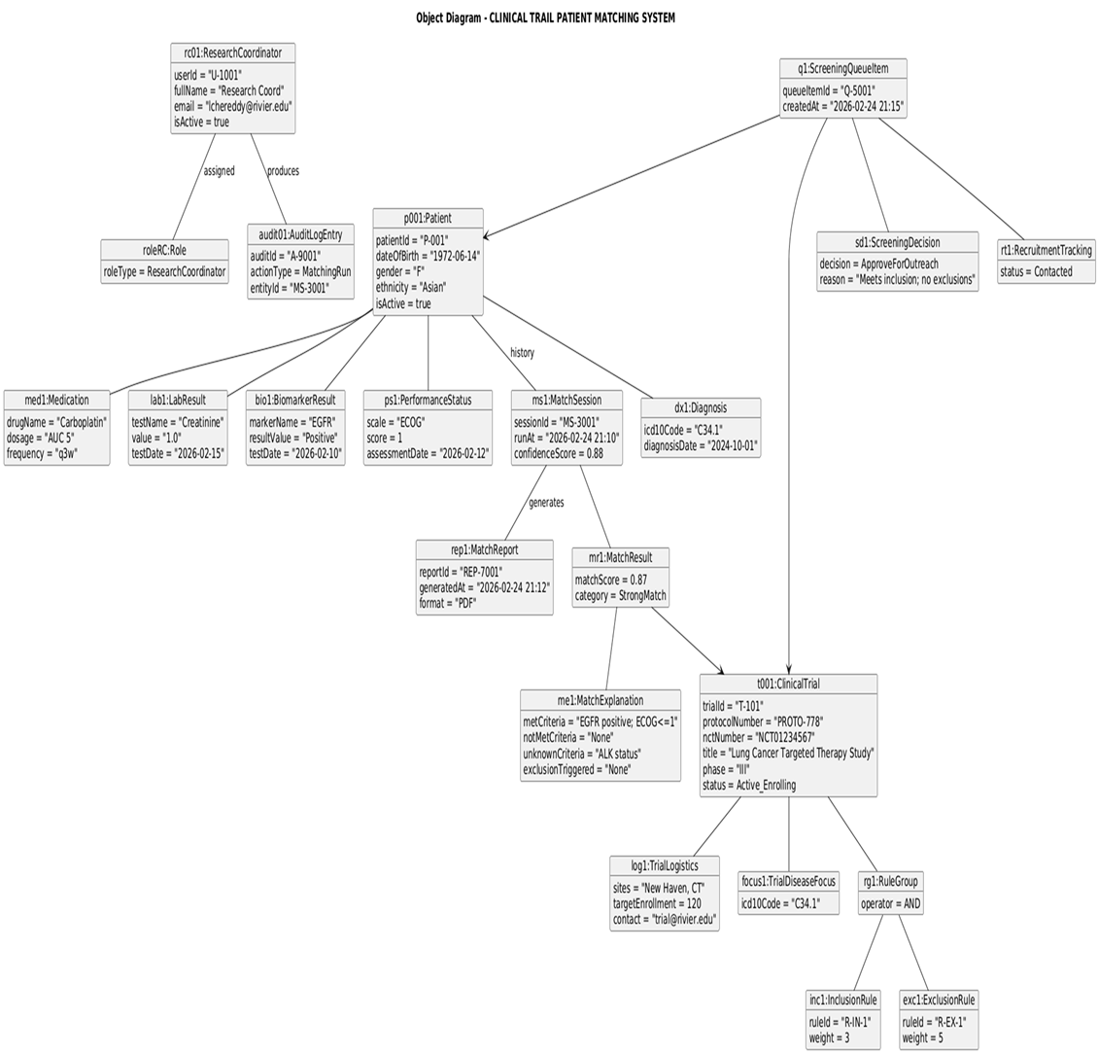
The object diagram illustrates a snapshot of the Clinical Trial Patient Matching System (CTPMS) during the evaluation of a patient for a clinical trial. It shows specific instances of the system’s classes and their relationships at runtime, including patient information, clinical trial details, matching results, screening decisions, and recruitment tracking. The diagram demonstrates how objects interact to represent a real scenario where a patient is evaluated, matched to a clinical trial, and processed through the screening workflow.
Figure 10: Object Diagram for the Clinical Trial Patient Matching System (CTPMS)

Design and Implementation Considerations
The Clinical Trial Patient Matching System (CTPMS) is designed based on the analysis models presented in this proposal to support efficient patient–trial matching and clinical trial recruitment management. The system architecture focuses on organizing system components in a structured manner so that patient data management, clinical trial configuration, automated matching, and screening workflows can operate reliably and efficiently. The design follows a layered structure that separates user interaction, system processing, and data storage responsibilities.
The user interface layer provides the environment through which system users interact with the system. Research Coordinators, Trial Administrators, and System Administrators access system features through this interface to perform tasks such as managing patient profiles, registering clinical trials, defining eligibility rules, running patient–trial matching, reviewing match results, and managing screening decisions. The interface is designed to present system outputs clearly so that users can quickly review matching results and make recruitment decisions.
The service layer contains the core system logic responsible for executing system operations. This layer manages key processes such as maintaining patient data, managing clinical trial information, evaluating eligibility rules, and executing the automated patient–trial matching process. The matching component evaluates patient clinical information against the eligibility criteria of active trials and generates match results along with explanations that help users understand the matching decisions. Additional service components support reporting functions, screening workflows, and recruitment tracking.
The data layer is responsible for storing and retrieving system information required by the application. It maintains structured records for patients, clinical trials, eligibility rules, match sessions, match results, screening decisions, and recruitment status updates. These repositories ensure that system data is stored securely and can be accessed efficiently during matching operations and reporting tasks. The system also records audit information to maintain traceability of important actions such as patient data updates and screening decisions.
Overall, this design approach provides a clear separation between system components while supporting the functional requirements defined earlier in the proposal. The layered architecture allows the system to be expanded or modified in the future while maintaining reliable management of patient–trial matching activities and clinical trial recruitment processes.
Recent research has also explored the use of intelligent methods to improve patient–trial matching and recruitment efficiency in healthcare systems (Wang & Liu, 2024).

References
- Dennis, A., Wixom, B. H., & Tegarden, D. (2020). Systems analysis and design (7th ed.). Wiley.
- Lee, J., Yoon, W., Kim, S., Kim, D., Kim, S., So, C. H., & Kang, J. (2021). Clinical trial information extraction with BERT. 2021 IEEE International Conference on Healthcare Informatics (ICHI). IEEE. https://doi.org/10.1109/ICHI52183.2021.00092
- ClinicalTrials.gov. (2025). Glossary of common site terms: Eligibility criteria. U.S. National Library of Medicine. https://clinicaltrials.gov/
- International Organization for Standardization. (2011). ISO/IEC 25010:2011 systems and software engineering—Systems and software quality requirements and evaluation (SQuaRE). ISO. https://www.iso.org/standard/35733.html
- Python Software Foundation. (2024). PEP 8 – Style guide for Python code. https://peps.python.org/pep-0008/
- World Health Organization. (2023). ICD-10 version 2019: International statistical classification of diseases and related health problems. https://icd.who.int/
- Wang, X., & Liu, X. (2024). Tackling no-show imbalance problems for healthcare appointment datasets. 2024 IEEE International Conference on Big Data (BigData). IEEE. https://doi.org/10.1109/BigData59044.2024.10386868
- Zhu, Y., Qin, L., He, B., & Xin, D. (2022). Design and implementation of laboratory appointment management system based on RFID. 2022 International Conference on Information System, Computing and Educational Technology (ICISCET). IEEE. https://doi.org/10.1109/ICISCET60440.2022.00059

